**Cluster Centers**

|  |  |
| --- | --- |
| **Cluster #** | **Cluster Center** |
| 1 | Average buy-clicks :: 0.02  Average Expenditure :: 0.03  Average ad-clicks :: 0.23  *Cluster size :: 589, 54% of dataset* |
| 2 | Average buy-clicks :: 0.94  Average Expenditure :: 4.30  Average ad-clicks :: 5.83  *Cluster size :: 390, 35.7% of dataset* |
| 3 | Average buy-clicks :: 1.58  Average Expenditure :: 20.19  Average ad-clicks :: 5.71  *Cluster size :: 112, 10.3% of dataset* |

These clusters can be differentiated from each other as follows:

Cluster 1(freeloaders) is different from the others in that…

It has captured most of the users that essentially play the game without spending at all and typically clicks on 1 advertisement in every 4-5 games. They provide the basic behaviour of the users in the game

Cluster 2(pennypinchers) is different from the others in that…

It is characterised as users who makes near to 1 purchase every level. Their expenditure is around $4.303 within a level. They also display a tendency to click on nearly 6 advertisements per level. It is much higher than the freeloaders.

Cluster 3(highrollers) is different from the others in that…

1.58 purchases per level(68% more than the pennypinchers) and spending almost $20 per level (470% more than the pennypinchers). Also ad-click rate is just slightly lower by 2% than penny-pinchers, they also click close to 6 advertisements per level which is much higher than the freeloaders

Log file from cluster analysis :

Highlighted text indicates details of the model selected for evaluation.

[SAMPLE DATASET]

[array([ 0., 0., 0.]), array([ 0.71428571, 8.57142857, 5.14285714]), array([ 0., 0., 0.]), array([ 0., 0., 0.]), array([ 0., 0., 0.]),

array([ 1.14285714, 3.71428571, 4.85714286]), array([ 2. , 31.5, 6.5]), array([ 1. , 6.5, 5. ]),

array([ 1.5 , 3.33333333, 5.66666667]), array([ 0., 0., 0.])]

[TRAIN DATASET SHAPE]

(1091, 3)

[K]=1

[CENTER(S)]

[array([ 0.50749203, 3.62997822, 2.79677448])]

[COST]=59925.05543342645

[CLUSTER SIZES]

dict_items([(0, 1091)])

[K]=2

[CENTER(S)]

[array([ 1.37703252, 17.03899811, 5.90320122]), array([ 0.35365747, 1.25772443, 2.24720167])]

[COST]=23212.28217540738

[CLUSTER SIZES]

dict_items([(0, 164), (1, 927)])

[K]=3

[CENTER(S)]

[array([ 0.93948718, 4.30493547, 5.8309768 ]), array([ 1.57476616, 20.18807802, 5.71264881]),

array([ 0.01850594, 0.03449349, 0.23324844])]

[COST]=12671.3123894749

[CLUSTER SIZES]

dict_items([(0, 390), (1, 112), (2, 589)])

[K]=4

[CENTER(S)]

[array([ 1.16061224, 11.48923622, 5.95703231]), array([ 0.01357597, 0.02816291, 0.15800116]),

array([ 1.84887218, 25.41132331, 5.46215539]), array([ 0.87687397, 2.79847867, 5.72487983])]

[COST]=7645.50590694292

[CLUSTER SIZES]

dict_items([(0, 140), (1, 577), (2, 57), (3, 317)])

[K]=5

[CENTER(S)]

[array([ 0.83032237, 2.41210121, 5.65188594]), array([ 1.14658163, 9.47171122, 6.06686224]),

array([ 0.01146922, 0.02439024, 0.14227642]), array([ 1.54826531, 19.3221017 , 5.38472789]),

array([ 2.28541667, 35.36238095, 6.1639881 ])]

[COST]=4983.973681127357

[CLUSTER SIZES]

dict_items([(0, 291), (1, 141), (2, 574), (3, 69), (4, 16)])

***<Log truncated for brevity. k=6 onwards not included here>***

Cost evaluation of cluster analysis

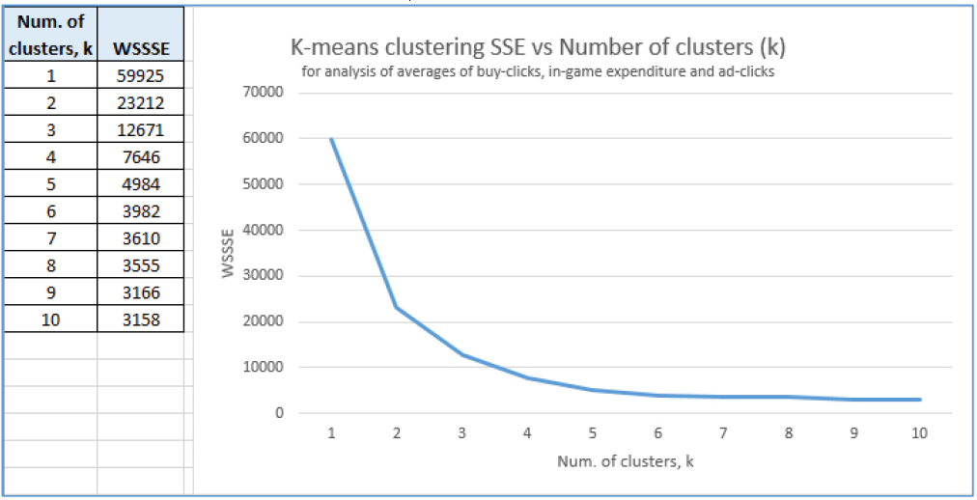

K=3 picked for evaluation of cluster analysis